Operational Research
  - Introduction to Simulation Answers
The following exercises will require the use of Excel. An example question and excel spreadsheet is given on Course Resources.

Exercises
- By Hand Complete the following table
Customer Arrival Time | Service Starts | Service Duration | Service Ends | Customer Waiting Time | Service Waiting Time
4 |  | 3
6 |  | 3
12 |  | 4
14 |  | 2
17 |  | 3

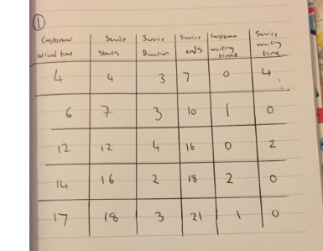
- Data has been collected at a service centre to enable the analysis and redesign of the service system.
Customers arrivals are described by the distribution
Inter-arrival Times | 5 | 10 | 15 | 20 | 25 | 30
Frequency  percentage | 10 | 20 | 40 | 20 | 7 | 3

Service times are given by
Service Duration | 10 | 12 | 14 | 16 | 20 | 30
Frequency  percentage | 5 | 20 | 45 | 20 | 9 | 1

Simulate the arrival of 30 customers, assuming that only the quoted times could occur, what does your simulation indicate about this system? What could be done to improve the system? *
Customer | Inter-arrival Time (IAT) | Arrival Time (AT) | Service Starts (SS) | Service Duration (SD) | Service Ends (SE) | Customer Waiting Time | Service Waiting Time
1 | Generate using random number | IAT(1) | AT(1) | Generate using random number | SS(1) + SD(1) | SS(1) – AT(1) | SS(1)
2 | Generate using random number | AT(1) + IAT(2) | Max{SE(1), AT(2)} | Generate using random number | SS(2) + SD(2) | SS(2) – AT(2) | SS(2) - SE(1)

- Jobs arrive every 15 minutes at a workshop comprising a single production stage.
Job arrivals are described by the distribution
Number of jobs arriving | 5 | 7 | 11 | 12
Frequency  percentage | 10 | 20 | 40 | 30

Service capacities (i.e. the number of jobs processed per 15 minutes) are given by
Jobs Capacity (Service Capacity) | 6 | 8 | 10 | 15
Frequency  percentage | 15 | 40 | 35 | 10

Simulate the production process over a period of 4 hours, what does your simulation indicate about this system? What could be done to improve the system? **

Time | No. Jobs Arriving  (JA) | Jobs in Queue  (JQ) | Jobs Capacity  (JK) | Jobs Completed  (JC) | Total Jobs Completed  (TJC) | Total Jobs Left  (TJL) | Unused Capacity  (UC)
1 (0-15) | Generate using random number | JA(1) | Generate using random number | Min{JQ(1),JK(1)} | JC(1) | JQ(1)-JC(1) | JK(1)-JC(1)
2 (15-30) | Generate using random number | JA(2)+ TJL(1) | Generate using random number | Min{JQ(2),JK(2)} | JC(1)+JC(2) | JQ(2)-JC(2) | JK(2)-JC(2)

